**Final Report: Project Title**

Report submitted to Fairfield University in partial fulfillment

of the requirements for the course of

IS 540: Data Mining and Business Intelligence

January 11, 2017

By

<Student Name as: FirstName LastName>

<Student Name as: FirstName LastName>

<Student Name as: FirstName LastName>

Course Instructor:

Dr. Jie Tao

Grade:

<To be filled by the instructor>

**Table of Contents**

0.Executive Summary

1. Introduction

1.1 Background

1.2 Research Question

1.3 List of Terms

1.4 Methodology

2. Analysis

2.1 Experiment Data

2.2 Data Processing

2.2.1 Imputation

2.2.2 Normalization

2.3 Modeling

2.3.1 Modeling Techniques

2.3.2 Evaluation

3. Results & Discussion

3.1 Interpretation

3.2 Comparison

4. Conclusion

Reference

Appendix A. Tables and Figures

Appendix B. Work Log

**Executive Summary**

Add text

**1. Introduction**

**1.1 Background**

Add text

**1.2 Research Question**

The research question of this project is: *How can we model the effect of macroeconomic factors on stock price?*

**1.3 List of Term**

Add text

**1.4 Methodology**

Throughout this project we used the Cross Industry Process for Data Mining (CRISP-DM) as a skeleton to base our project on.

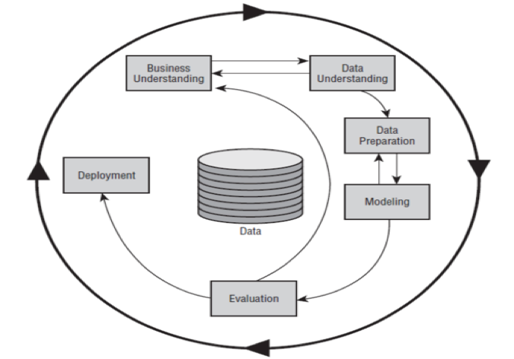

**Figure 1. Phases of the CRISP_DM reference model**

***Business Understanding***

Add text

**Data Understanding**

Add text

**Data Preparation**

Add text

**Modeling**

Add text

**Evaluation**

Add text

**Deployment**

Add text

**2. Analysis**

**2.1 Experiment Data**

Add text

**Observation selection**

Add text

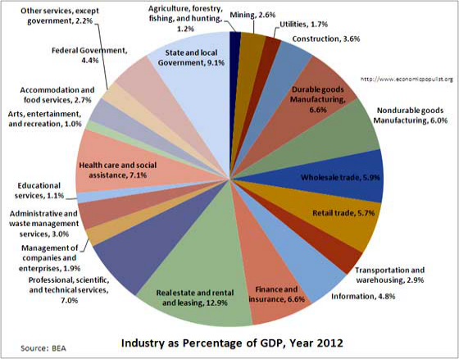

**Figure 2. An Nice Example of Colored Diagram**

**Variables selection**

Add text – compare pairs of variables using correlation

**Consumer Price Index for All Urban Consumers: All Items**

**Consumer Price Index for All Urban Consumers: All Items Less Food & Energy (.999)**

We have chosen to move out “Consumer Price Index for All Urban Consumers: All Items Less Food & Energy” as we would like to look at the Consumer Price Index for all items including food and energy. Although a very minor difference, we believe that this may help in modelling any company that is within the food or energy sector

**2.2 Data Processing**

Add text

**Table 2. An Example of a Nice Table**

|  |  |  |
| --- | --- | --- |
| The 16 companies’ data | FRED daily data | FRED monthly data |
| 1/29/Year 1/30/Year 1/31/Year | 1/29/Year 1/30/Year 1/31/Year | 2/1/Year |
| 4/28/Year 4/29/Year 4/30/Year | 4/28/Year 4/29/Year 4/30/Year | 5/1/Year |
| 7/29/Year 7/30/Year 7/31/Year | 7/29/Year 7/30/Year 7/31/Year | 8/1/Year |
| 10/29/Year 10/30/Year 10/31/Year | 10/29/Year 10/30/Year 10/31/Year | 11/1/Year |

**2.2.1 Imputation**

Add text

**2.2.2 Normalization**

Add text

**2.3 Modeling**

**2.3.1 Modeling Techniques**

Add text

**ARIMA**

Add text

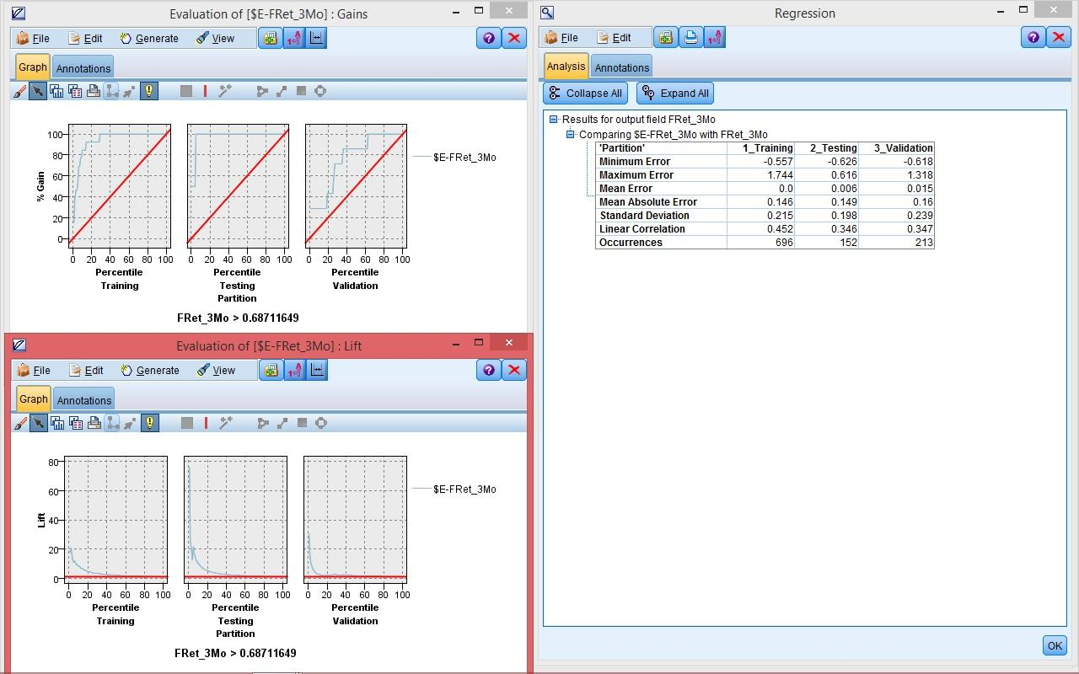

**Figure 3. A Good Example of Screenshot**

**2.3.2 Evaluation**

Add text

**3. Results & Discussion**

**3.1 Interpretation**

Add text

**3.2 Comparison**

Add text

**4. Conclusion**

Add text

**5. Lessons Learned**

**5.1 What and how we did in project? What we learned?**

Add text

**5.2 What we can improve in next project?**

Add text

**6. Reference**

Add text

**7. Appendices**

**7.1 Appendix A: Tables and Figures**

**Tables: Put descriptive statistics, data dictionary, and other data understanding tables here**

**Figures: Put Results, Visualizations, and Screenshots here**

**7.2 Appendix B. Work Log**

Table 17. Work Log

|  |  |  |  |  |
| --- | --- | --- | --- | --- |
|  | Student 1 | Student 2 | Student 3 | Student 4 |
| Imputation Method | Overall Mean | Moving Mean | ARIMA | Linear |
| Presentation | Host & Page 1-4 | Page 17-25 | Page 14-16 & Page 26-28 | Page 5-13 |
| Report | 0.Executive Summary | 2. Analysis | 2.Analysis | 2. Analysis |
|  | 1. Introduction | 3. Results & Discussion | 4. Conclusion | Appendix |
|  |  | 4. Conclusion |  |  |